Deborah Manning School of Dance
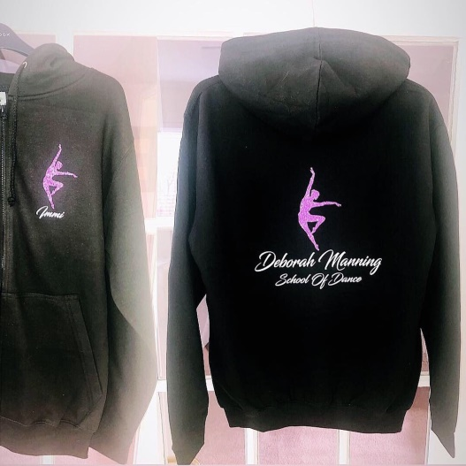
Black Hoodie
Age 3-4 Years - £20.00
Age 5-6 Years - £22.00
Age 7-8 Years - £24.00
Age 9-11 Years - £26.00
Age 12-14 Years - £28.00
Small Adult (UK8) - £32.00
Medium Adult (UK10) - £34.00
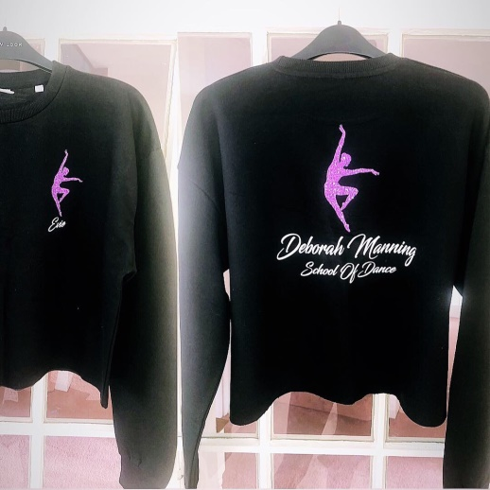
Black Cropped Hoodie
Extra Small Adult - £30.00
Small Adult (UK8) - £32.00
Medium Adult (UK10) - £34.00

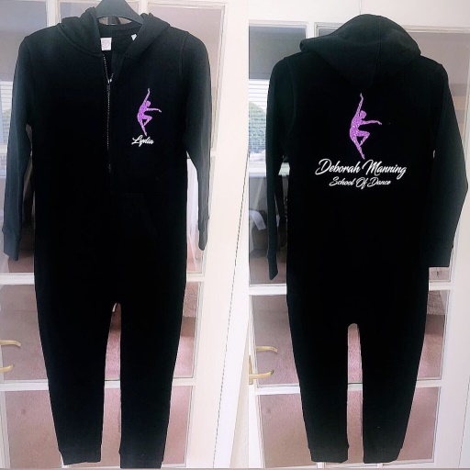
Black Onesie
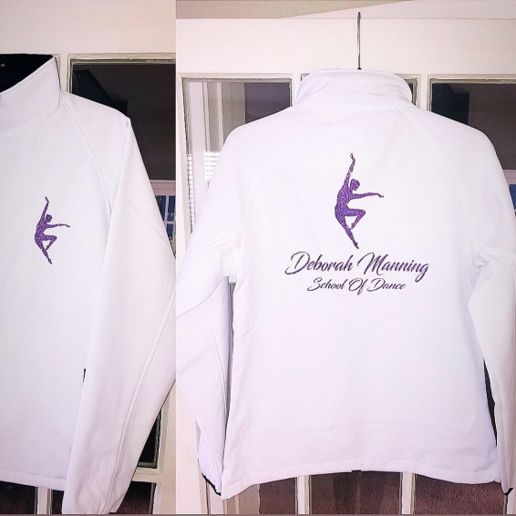
Age 3-4 Years - £26.00
Age 5-6 Years - £27.00
Age 7-8 Years - £28.00
Age 9-11 Years - £29.00
Age 12-14 Years - £30.00
Extra Small Adult (UK6) - £36.00
Small Adult (UK8) - £37.00
Medium Adult (UK10) - £38.00

White Shell Jackets
Extra Small Adult (UK8) - £40.00
Small Adult (UK10) - £41.00
Medium Adult (UK12) - £42.00

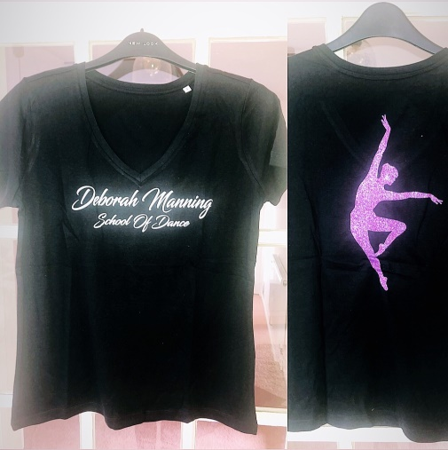
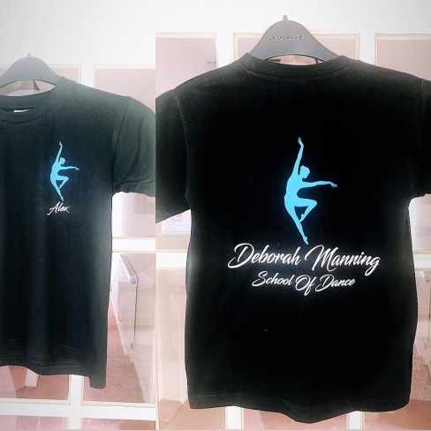
Black T-Shirts (£18)
Age 3-4 Years
Age 5-6 Years
Age 7-8 Years
Age 9-11 Years
Age 12-13 Years
Extra Small Adult
Small Adult
Medium Adult

Pink Dance Bag (£15) – No Personalisation
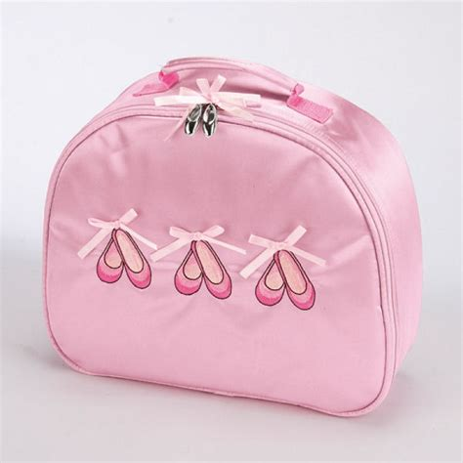

Small Dance Bag (£25) Large Dance Bag (£30)
