Wednesday 1st July 2020
Written By Deborah Manning, Principal

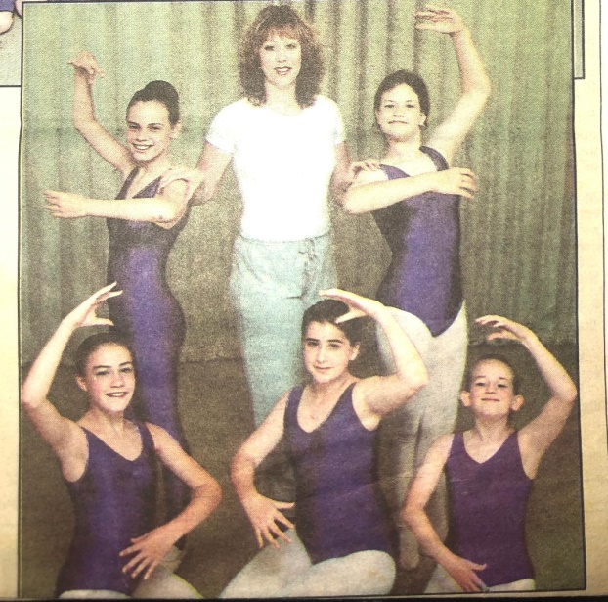
Dear Parents/Guardians,
I do hope you are all keeping well during this difficult and at times overwhelming period we have all found ourselves in. However, it is wonderful that things are now starting to get back to some normality.
I would like to take this opportunity to thank you all for your support, particularly over the past four months. The dancing lessons offered online via Zoom have gone even better than I could have imagined and I would like to thank Connie personally for organising these.
I am writing to inform you, that after contemplating for a long time, I have decided to step down as Principal of the school at the end of August in preparation for the new Term starting September 2020.
This has not been an easy decision, but one I feel has come at the right time for myself and the school.
After graduating from Performing Arts School I already knew that teaching was my passion and that I wanted to set up my own Dancing School where children could be taught in a caring and loving environment, but at the same time learn the discipline of dance which I so loved from an early age. As I was born with a club foot my mother was advised by my Orthopaedic Surgeon to take me to Ballet lessons to build up the muscles in my ankle and leg, which she did and I started lessons at the age of two and a half and the rest is history!
I started the school twenty eight years ago this September, with only a small handful of students at Freeland Village Hall. I never dreamed that it could become what it is today. With over one hundred and forty students now enrolled in weekly lessons of Ballet, Tap, Lyrical, Contemporary, Acrobatics, Modern Jazz, Pointe, the list goes on... We now even have a new genre of Urban Dance starting online by Miss Georgia; a student who started dancing with me when she was only two and a half years of age!
The Dance School has been a major part of my life and my family’s life for twenty eight years and it has now come to a lovely time where previous students have now enrolled their own children.

I have lost count of the numerous Dance Shows, Examinations and Parent Watching Days we have had over the years and have appreciated the support from you all.
It has been lovely to watch students flourish and begin to pursue their careers in many different roles even if not in dance. It was always my aim to help bring out their confidence and self esteem as young adults ready for the next chapter of their lives.
I have thoroughly enjoyed my time managing, teaching and nurturing all past and present students during my time as Principal in the discipline of dance and at the same time raising a family of my own.
During my time as Principal both my daughters Connie and May have watched and danced alongside mummy as she worked; my youngest daughter May is now a keen actress and dancer and my eldest daughter Connie a teacher, who you all know extremely well and who the students seem to love. Connie started to help me teach at the age of fourteen when I had my first ankle operation and was the youngest person in U.T.D. at seventeen years of age to take her Ballet Teaching Fellowship Exam. Connie has been Deputy Principal in the school for a number of years now and supportive in many decisions I have made within the school.
Therefore I feel it is only natural that my daughter Connie takes over as Principal from the 1st September 2020.
Even though I am stepping down as Principal, I shall continue to teach mainly Ballet and some other genres within the school each week and support Connie in her new role. At this moment in time, the Timetable for September has not yet been finalised with which classes I shall be teaching from September.
I will also be continuing to work as a U.T.D. Examiner.
Lastly, I do hope you will all congratulate and support Connie in her new role.
With very best wishes to you all and thank you.
Deborah Manning
Principal & U.T.D. Examiner

